To our Dearest Guests
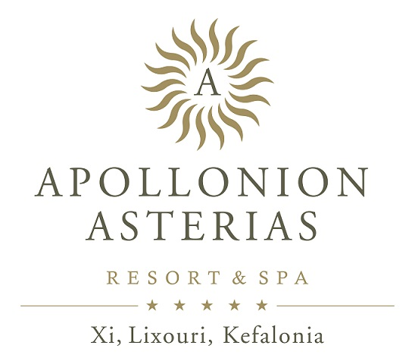

We welcome you at Apollonion Asterias Resort & Spa, we would like to inform you about the new way of operation of our accommodation,
according to the guidelines set by the Hellenic National Public Health Organization (EODY) and according to the Greek Government’s instructions in order to prevent the
COVID-19 transmission.

HOUSEKEEPING: We inform you that before your arrival your room has been sanitized by using special approved anti-bacterial cleaning products and a steam cleaner according to the respective EODY guidelines

Therefore for your convenience please select one out of the 2 options offered below:

NO HOUSEKEEPING AT ALL DURING MY STAY: ……………..

HOUSEKEEPING EVERY 2 DAYS: ……..……….

Please note that if you request Housekeeping then we will enter the room only with your absence in order to avoid overcrowding the room.

In the case that you have chosen NO housekeeping and you would need a change of sheets/towels or us to take away your rubbish, please contact the reception.

(PLEASE NOTE, you cannot leave these out at any time, so we can avoid any microbial outbreak)

ARRIVAL – DEPARTURE: According to the new Health Regulations, the time of arrival is from 15.00 and the time of departure is at 11.00 so there is enough time to sanitize the rooms for the next arrival.

BREAKFAST

Breakfast is served at Primavera Restaurant (buffet) 07:30 – 10:30 am.

Early Breakfast 7:00 – 7:30 only upon request (masks and disposable gloves are provided)

LUNCH all Incl.

Lunch is served at Primavera Restaurant (buffet) 12:30 – 14:30 am (masks and disposal gloves are provided)

DINNER

Dinner is served at Primavera Restaurant (buffet) 19:00 – 22:00 am (masks and disposal gloves are provided)

BARS
Asterias Pool Bar: 10.00 – 18.00 (self service), Cold sandwiches & Fruit
16.30–17.30: Coffee Break – Selection of tea, filter coffee and cake
Apollo Music Bar: 18.00 – 00.00
Medeo Pool Bar: closed in low season

SPA

10.00 – 19.00 all therapies take place after reservation (please visit our spa to make your appointment)
Wet Area: Not Allowed to be used due to COVID protocol restrictions
Gym: Up to 2 pax can enter therefore please refer to spa reception.

La Pergola
Opening Hours: 12.00 – 17.00
All Inclusive Snacks 11:00 - 12:30: Fruits & Hot Snacks
14:30 – 17:00: Hot Snack

Trattoria
Friday and Saturday at 19:30
Wednesday or Thursday at 19:00 (all inclusive-once on your accommodation)

POOLS

Working hours: 10.00 – 18.00. Please shower before entering the pool.
Tables, Parasols and sun loungers are placed in order for appropriate distances to be kept according to protocols. Please do not change positions.

Please note that the use of a face mask is obligatory in all closed areas.

In the case that you or any member of your family does not feel well please contact the reception.

Guest’s Signature

Thank you ever so much for your understanding!

